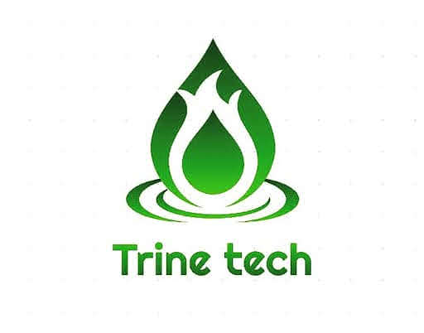

**The Problem**

Our solution addresses the problem associated with food waste, power scarcity for food processing and use of chemical fertilizers, both in the industrial and domestic level. Our target, is to meet up with the upstream (the crop production sector), midstream (the storage and processing sector) and downstream (the import and export sector) sectors of the agricultural value chain due to the large quantity of waste, generated by these sectors. We intend to turn their waste into our gold, by launching an intentional series of products that originate from the same technology but in their way meet the specific needs of each part of the value chain above and are also powered by their own waste. Therefore, in the long run, our solution meets the following SDG goals which are; good health and well being, affordable and clean energy, sustainable cities and communities, climate action, life on land and finally, partnerships for goals.

**Product and the Development**

With the guidance of experts at the National Energy Research And Development Centre University of Nigeria Nsukka and material collected from the 2011 United State Forces, energy project in Afghanistan, we have been able to come up with a prototype that has the ability of producing an alternative means of energy called the bio-gas, but also in the same process, produce a by-product called the bio-fertilizer (which is highly rich in N.P.K for crop production), using food waste (cassava) as a power source through the process of anaerobic digestion using bio-recyclers.

**Market Potential of Our Solution**

We are currently improving our prototype and carrying out researches for a more suitable material that is locally available due to the corrosive nature of gas, so to ensure that we deliver a safe and affordable product to our target market, hence, from our previous surveys and community pitch events we have received optimistic feedback from different potential customers, medium scale farmers and some community groups, all with the willingness to pay for the product whenever it is ready. So, we hope to have a rewarding market share whenever we launch our products.

**Team**

We are a team of proactive students who are passionate about our business, we are good in what we do, because of how unique our products are and we are willing and determined to see to the growth of our economy through this business and improve the chances of us leading our generation to change the world in our sector of operation.